Keith Wheeler

CS - 165 Comeau

Project 2 – MoonLander

Design Overview – The program will draw the ground, platform, and lander then allow the player to use the left, right, and bottom thrusters to land on the platform.

Interface design -

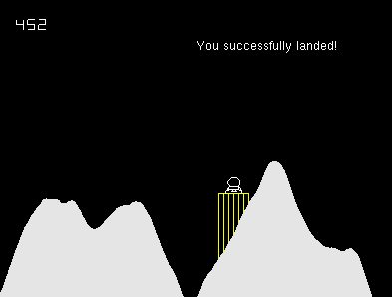

Data structures –

All bools will be either true or false, therefore you are either dead or not, you landed or you crashed.

Int fuel will keep track and display the used fuel. It will start from 500 and count down.

Int xSize will help display the ground.

Float x and Float y keep track of where the lander is on the screen compared to the ground, platform, and edge of the screen.

